NAME:MANJU SRI
EXNO:01
CREATE A RESPONSIVE WEBPAGE USING CSS FLEXBOX TO STRUCTURE
CONTENT IN A GRID LAYOUT
<!DOCTYPE html>
<head>
<meta name="viewport" content="width=device-width, initial-scale=1" />
<title>Manju Sri Resume</title>
<style>
body {
margin: 0;
font-family: 'Segoe UI', Tahoma, Geneva, Verdana, sans-serif;
background: linear-gradient(120deg, #dfe9f3, #ffffff);
}
.resume {
max-width: 800px;
margin: 40px auto;
background: #ffffff;
padding: 40px 50px;
border-radius: 10px;
box-shadow: 0 10px 25px rgba(0, 0, 0, 0.1);
}
header {
text-align: center;
margin-bottom: 30px;
}
header h1 {
margin: 0;
font-size: 32px;
color: #2c3e50;
}
header h3 {
margin: 5px 0 0;
color: #3498db;
font-weight: 500;
font-style: italic;
}
section {
margin-bottom: 25px;
}
section h2 {
color: #2c3e50;
border-bottom: 2px solid #3498db;
padding-bottom: 5px;
margin-bottom: 10px;
font-size: 20px;
font-weight: 600;
}
p, ul {
color: #4a4a4a;
line-height: 1.5;
}
ul {
padding-left: 20px;
}
ul li {
margin-bottom: 6px;
}

strong {
color: #2c3e50;
}
</style>
</head>
<body>
<div class="resume">
<header>
<h1>Manju Sri</h1>
<h3>Full Stack Web Developer</h3>
</header>

<section>
<h2>Objectives</h2>
<p>
Passionate frontend developer with experience in building responsive and user-friendly websites using HTML, CSS, and JavaScript.
</p>
</section>
<section>
<h2>Education</h2>
<p><strong>Bachelor of Computer Science</strong><br />Sarah Tucker College (2022 – 2025)</p>
<p><strong>Master of Computer Science</strong><br />Adhiyamaan College of Engineering (2025 – 2027)</p>
</section>
<section>
<h2>Personal Details</h2>
<p><strong>Email:</strong> manju@email.com</p>
<p><strong>Phone:</strong> +123 456 789</p>
<p><strong>Location:</strong> Tirunelveli</p>
<p><strong>Experience:</strong> 0Years</p>
</section>
<section>
<h2>Skills</h2>
<ul>
<li>HTML5 / CSS3</li>
<li>CSS</li>
<li>Python</li>
<li>JavaScript (Basic)</li>
<li>Git & GitHub</li>
</ul>
</section>
<section>
<h2>Certification</h2>
<ul>
<li>Red Hat</li>
<li>Presentations</li>
<li>Seminars</li>
<li>Workshops</li>
<li>Courses</li>
</ul>
</section>
</div>
</body>
</html>

OUTPUT:
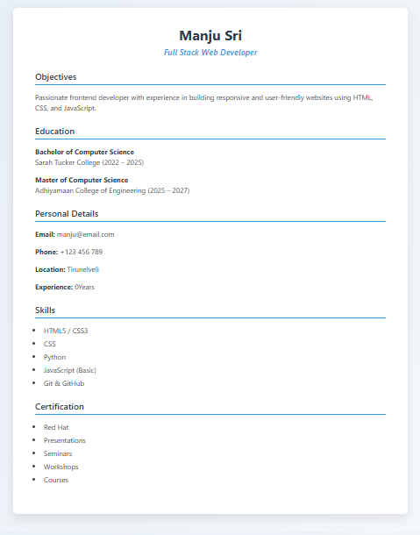

NAME:MANJU SRI
EXNO:02
BUILD A SIMPLE FORM VALIDATION USING JAVASCRIPT TO VALIDATE INPUT FIELDS LIKE NAME,EMAIL,AND PASSWORD

<!DOCTYPE html>
<html>
<head>
<title>Form Check</title>
</head>
<body>
<h3>Submit Details</h3>
<form onsubmit="return checkDetails()">
Name: <input type="text" id="name"><br><br>
Email: <input type="text" id="email"><br><br>
Password: <input type="password" id="password"><br><br>
<input type="submit" value="Submit">
</form>
<script>
function checkDetails() {
var correctName = "manjusri";
var correctEmail = "manjusri@gmail.com";
var correctPassword = "1234";
var name = document.getElementById("name").value;
var email = document.getElementById("email").value;
var password = document.getElementById("password").value;
var isValid = (name === correctName &&
email === correctEmail &&
password === correctPassword);

alert(isValid ? "Submitted Successfully!" : "Wrong Details! Try again.");
return isValid;
}
</script>
</body>
</html>

OUTPUT:
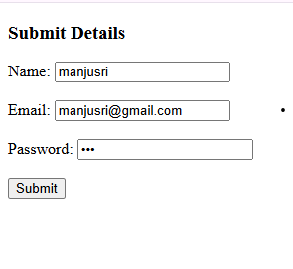

NAME:MANJUSRI
EXNO:04
CREATE A SIMPLE WEB SERVER USING PHP WITH MYSQL

Database.php
<?php
$conn=mysqli_connect("localhost","root","");
if(!$conn)
{
die("connect failed:".mysqli_connect_error());
}
$sql="CREATE DATABASE job";
if(mysqli_query($conn,$sql))
{
echo "database created successfully";
} else
{
echo "error creating database".mysqli_error($conn);
} mysqli_close($conn);
?>
Output:


Table.php
<?php
$conn=mysqli_connect("localhost","root","","job");
if(!$conn)
{
die("connect failed:".mysqli_connect_error());
}
$sql="CREATE TABLE emp(EmpID INT PRIMARY KEY,
Name VARCHAR(50),
Department VARCHAR(50),
Salary INT,
City VARCHAR(50))";
if(mysqli_query($conn,$sql))
{
echo "tables created successfully";
}
else
{
echo "error creating tables".mysqli_error($conn);
}
mysqli_close($conn);

?>
Output:


Insert.php
<?php
$conn = mysqli_connect("localhost","root","","job");
if(!$conn){
die("connect failed: " . mysqli_connect_error());
}
$sql1 = "INSERT INTO emp VALUES(1, 'manju', 'manager', 45000, 'tirunelveli')";
$sql2 = "INSERT INTO emp VALUES(2, 'Priya', 'client', 50000, 'Bangalore')";
$sql3 = "INSERT INTO emp VALUES(3, 'nancy', 'HR', 60000, 'chennai')";
$sql4 = "INSERT INTO emp VALUES(4, 'baviya', 'Marketing', 42000, 'hosur')";
$sql5 = "INSERT INTO emp VALUES(5, 'magi', 'IT', 54000, 'madurai')";
$sql6 = "INSERT INTO emp VALUES(6, 'maha', 'HR', 37000, 'theni')";
$sql7 = "INSERT INTO emp VALUES(7, 'gomu', 'Sales', 42000, 'ambai')";
$sql8 = "INSERT INTO emp VALUES(8, 'sankar', 'Finance', 22000, 'Kashmir')";
$sql9 = "INSERT INTO emp VALUES(9, 'faizal', 'Support', 80000, 'vellore')";
$sql10 = "INSERT INTO emp VALUES(10, 'noor', 'IT', 10000, 'Chennai')";
mysqli_query($conn, $sql1);
mysqli_query($conn, $sql2);
mysqli_query($conn, $sql3);
mysqli_query($conn, $sql4);
mysqli_query($conn, $sql5);
mysqli_query($conn, $sql6);
mysqli_query($conn, $sql7);
mysqli_query($conn, $sql8);
mysqli_query($conn, $sql9);
mysqli_query($conn, $sql10);
echo "Inserted successfully";
mysqli_close($conn);
?>

:
Delete.php

<?php
$conn=mysqli_connect("localhost","root","","job");
if(!$conn)
{
die("connect failed:".mysqli_connect_error());
}

$sql="DELETE FROM emp where Name='noor'";
if(mysqli_query($conn,$sql))
{
echo "delete data successfully";
}
else
{
echo "error in delete data".mysqli_error($conn);
}
mysqli_close($conn);
?>

Output:

Display.php
<?php
$conn=mysqli_connect("localhost","root","","job");
if(!$conn)
{
die("connect failed:".mysqli_connect_error());
}
$sql="SELECT EmpID,Name,Department,Salary,City from emp";
$result=mysqli_query($conn,$sql);
if(mysqli_num_rows($result)>0)
{
while($row=mysqli_fetch_assoc($result))
{
echo "EmpID".$row["EmpID"]."Name".$row["Name"]."Department".$row["Department"]."Salary".$row["Salary"]."City".$row["City"]."<br>";
}
}
else
{
echo "error in displaying data".mysqli_error($conn);
}
mysqli_close($conn);

?>
Output:
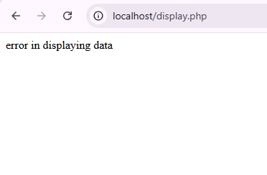
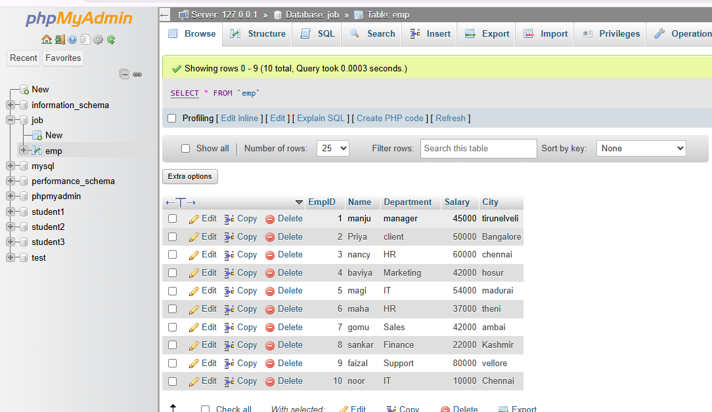

NAME:MANJU SRI
EXNO:03
IMPLEMENT SESSION USING PHP

Login.php
<?php
session_start();
if (isset($_POST['submit'])) {
$_SESSION['username'] = $_POST['username'];
header("Location: dashboard.php");
exit();
}
?>
<!DOCTYPE html>
<html>
<head>
<title>Login</title>
</head>
<body>
<h2>Login</h2>
<form method="post">
Username:
<input type="text" name="username" required>
<br><br>
<input type="submit" name="submit" value="Login">
</form>
</body>
</html>

Dashboard.php
<?php
session_start();
if (!isset($_SESSION['username'])) {
header("Location: login.php");
exit();
}
?>
<!DOCTYPE html>
<html>
<head>
<title>Dashboard</title>
</head>
<body>
<h2>Welcome</h2>
<?php
echo "Hello, " . $_SESSION['username'];
?>
<br><br>
<a href="logout.php">Logout</a>
</body>
</html>
Logout.php
<?php
session_start();
session_unset();
session_destroy();
header("Location: login.php");
exit();

OUTPUT:

